**SHOPPING LIST NOTIFICATIONS SYSTEM**

**Software Requirement Specification (SRS) Document**

**Sprint 2 Implementation**

**Project Timeline:22-02-2023 to 6-03-2023**

**SOFTWARE REQUIREMENT SPECIFICATIONS**

**Project Name: SHOPPING LIST NOTIFICATIONS SYSTEM**

**Document Title: SRS**

**Project Timeline: 22-02-2023 to 6-03-2023**

**INDEX**

**1. Introduction**

1.1 Purpose

1.2 Intended audience

1.3 Intended use

1.4 Scope

**2. Overall Description**

2.1 Assumptions and Dependency

**3. System feature and requirements**

**3.1 Functionality**

3.1.1 ELMS_01 -> **new_user_registration()**

3.1.2 ELMS_02-> **user_login()**

3.1.3 ELMS_03-> **admin_user_interface()**

3.1.4 ELMS_04-> **admin_login_interface()**

3.1.5 ELMS_05-> **validate_login()**

3.1.6 ELMS_06 -> **validate_Id()**

3.1.7 ELMS_07-> **validate_product()**

3.1.8 ELMS_08-> **admin_login()**

3.1.9 ELMS_09-> **load_sunscribe_products()**

3.1.10ELMS_10-> **save_subscribe_product()**

3.1.11ELMS_11-> **write_to-subscribe_product()**

3.1.12ELMS_12->**viewProducts()**

**3.2 System requirement**

3.2.1 Software requirements

3.2.2 Hardware requirements

3.2.3 System features

**4. Data Flow Diagrams**

4.1 DFD level 0

4.2 DFD level 1

**5.Appendix**

**1.Introduction**

The introduction of the software requirement specification provides an overview of the entire software. The entire SRS covers overview description, purpose, scope, tools used and basic description. The aim of this document is to gather, analyse and give an in-depth insight into the **SHOPPING LIST NOTIFICATIONS SYSTEM** by defining the problem statement in detail.

The detailed requirements of theshopping List Management System

is provided in this document.

**1.1 Purpose:**

The purpose of this document is to show the requirements for the Shopping List notification System which creates a direct contact between the

**1.2 Intended Audience:**

There is no such specific audience, it could be User.

**1.3 Intended Use:**

* Retailers
* Customers

**1.4 Scope:**

This project aims to develop the Shopping List Notifications System. This system helps the users to subscribe for products and get the notifications regarding them.

**2. Overall Description**

The Shopping List Notification System is designed to make the shopping experience smooth for the users.

The admin that is retailers will prepare the shopping list and handle it by adding and updating the product details.

The users that are customers subscribes for the products available in the list and if there is change in the price of subscribed products the user is notified with the same.

**2.1 Assumptions and Dependency:**

* System should have any flavour of Linux installed.
* System should have either 4GB or more RAM.
* The service is used preferably on a desktop or laptop.

**3. System Features and Requirements**

**3.1 Functionality:**

**3.1.1 ELMS_01 -> new_user_registration()**

Allows user to register himself for creating login credentials

**3.1.2 ELMS_02->**  **user_login()**

After successful registration, user can login with the credentials received.

**3.1.3 ELMS_03-> int admin_user_interface()**

This function will handle the admin menu.

**3.1.4 ELMS_04->** **int admin_login_interface()**

This function will handle the Registration and login process of admin

**3.1.5 ELMS_05-> validate_login()**

This function will check the login details entered with the details stored in the file.

**3.1.6 ELMS_06 -> validate_Id()**

**3.1.7 ELMS_07-> validate_product()**

**3.1.8 ELMS_08-> admin_login()**

**3.1.9 ELMS_09-> load_sunscribe_products()**

**3.1.10ELMS_10-> save_subscribe_product()**

**3.1.11ELMS_11-> write_to-subscribe_product()**

**3.1.12ELMS_12->viewProducts()**

**3.1.13ELMS_13->admin_validate_login**

**3.1.14ELMS_14->load_admin_data()**

**3.1.15ELMS_15->login_interface()**

**3.1.16ELMS_16->load_user_data()**

**3.1.17ELMS_17->validate_login()**

**3.1.18ELMS_18->write_to_file()**

**3.1.19ELMS_19->user_interface()**

**3.1.20ELMS_20->admin_main()**

**3.2 System Requirements:**

**3.2.1: Software Requirements:**

* + - * Operating System -Windows 11
      * Server-side script - C++ Language
      * IDE - Putty
      * Libraries used - C++ libraries

**3.2.2: Hardware Requirements:**

* Processor - i5/Intel Processor
* RAM - 4GB (min)
* Hard Disk - 128 GB
* Keyboard - Standard Keyboard
* Mouse - Two or three button mouse
* Monitor - Any

**3.2.3: Tools and methods to be used:**

* Valgrind
* Gcov
* STL library
* C++ File Handling
* Make multiple files

**3.3 System Features:**

* **Supportability:** The system is easy to use.
* **Design Constraint:** The system is built using only C++ language.
* **Usability:** The Secure banking application is used to do the transactions by using this online application without going to the banks.
* **Reliability & Availability:** The application is available 24/7 that is whenever the customer would like to use the application. The customer simply login it.
* **Performance:** The system will work on the user’s terminal.

**4. Data Flow Diagrams**

**4.1 DFD Level 0:**

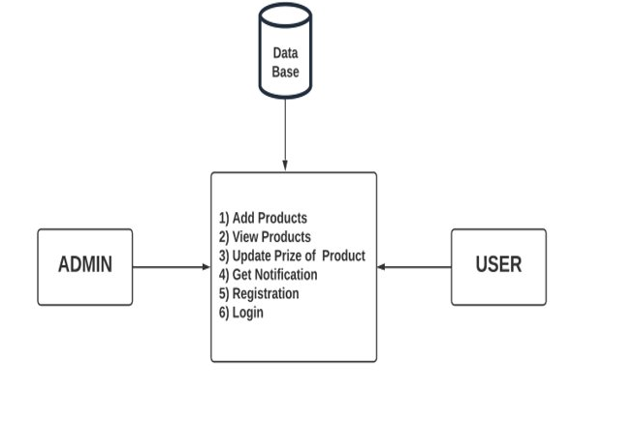

**4.2: DFD Level 1:**

**6.Appendix**

1. C++ Language Reference: <https://en.cppreference.com/w/cpp>
2. Microsoft C++ Language Reference: <https://docs.microsoft.com/en-us/cpp/cpp/cpp-language-reference>
3. GeeksforGeeks C++ Reference: <https://www.geeksforgeeks.org/c-plus-plus/>
4. Programiz C++ Reference: <https://www.programiz.com/cpp-programming/library-function>
5. Tutorialspoint C++ Reference: <https://www.tutorialspoint.com/cplusplus/cpp_standard_library.htm>
6. W3Schools C++ Reference: <https://www.w3schools.com/cpp/default.asp>
7. Stack Overflow C++ Reference: <https://stackoverflow.com/questions/tagged/c%2B%2B>
8. CppShell C++ Reference: <https://www.cppshell.com/reference/>
9. CppReference C++ Reference: <https://en.cppreference.com/w/cpp/links/libs>